Zone Briefing Package
BC Wildfire Service

Invermere Fire Zone


Contents
Contents 1
Welcome to Invermere 1
Initial Attack Procedures 3
Unit Crew Procedures 3
Fireline Expectations 3
Finance and Documentation 3
Communication 4
Crew Rotation 4
Road Access Fires 4
Hazards 4
Certifications 4
SEFC Standby 5
Site Support Level 6
Base Procedures 7
Radio Operations and Dispatch Procedures 9
Repeaters 10
SEFC Type 3-4 Incident Commander Updates 11
Zone Organization Chart 12
Contacts 13
Location 14
Fuel Caches 15
Weather Stations 16
Food & Accomodation 17
Zone Map 18

Welcome to invermere
The zone office is located at 625 Fourth St, Invermere, BC. There are roughly 7000 permanent residents across the communities of the Upper Columbia Valley consisting of Edgewater, Radium, Invermere, Windermere and Canal Flats in the South. The valley is a popular summer destination for Albertans and sees a large influx of tourists and second homeowners in the warmer months. Timber harvesting, ranching and tourism/recreation are the main economic drivers in the region.

The Rocky Mountain Forest District is over 2.6 million hectares in size and stretches from Golden in the north to the BC/Montana border in the south. The climate of the area is generally characterised by hot, very dry summers with cool winters and generally light snowfall although this changes with elevation. Tree species in the area range from subalpine larch and Engelmann spruce in the high elevation areas to the classic western larch and ponderosa pine forests of the low country. The district is composed of two Wildfire Zones: Cranbrook and Invermere.

The Invermere Zone is bounded by the Skookumchuck Valley to the south, the town of Golden to the north, the National Mountain Parks and Alberta border to the east, and the southern Purcell Mountains height-of-land to the west. Three major physiographic regions characterize the varied terrain of the Invermere Zone: The Rocky Mountains in the east, the Purcell Mountains in the west, and the Rocky Mountain Trench in the middle.

Things to be aware of within the Zone: strong winds influenced by mountainous terrain, steep terrain, high temperatures, low humidity’s, high tourist traffic in summer months, numerous provincial and federal parks. Local wildlife consists of grizzly and black bears, cougars, wolves, coyotes, elk, mountain goats and big horn sheep.

INITIAL ATTACK PROCEDURES
- Due to extremely rough terrain and remote locations, most fires in zone are helicopter access only. It is common practice to dispatch 2 or 3 members of an IA crew by Helicopter, with the 3rd following in an IA truck to support.
- Overnighting is common on IA fires, always be prepared to overnight. Seek approval from the RWCO or ZWCO.
- Always get a clear 8 hour break every operational period, unless No Clear 8 is approved due to values at risk.
- Please arrive at 08:30 am daily unless notified otherwise.
- Prep/Weather call is held at 10:15 Mondays and Thursdays.
- Hover exiting onto IA Fires is common, ensure you brief and complete dry runs when working with a different pilot or aircraft
- All personnel and gear must be weighed, and total payload communicated to pilot and SEFC dispatch.

OUt of Zone Crews

Please report to the ZWCO immediately with the following info:
  - Are your accommodations booked?
  - Number of fallers
  - What is your gear compliment?
  - Receive a briefing and set of keys to access the compound

FIRELINE EXPECTATIONS
- Follow all OSWS procedures.
- Either hand or machine guard is expected to be constructed around all fires in the Invermere zone. If this is unachievable for any reason, a discussion must be had with the ZWCO.
- Fuel Free should be a minimum of 1.5m.
- Pre plan medevac options, if relying on hoist extraction, ensure site is pre-determined and you have communicated plans to dispatch.
- Be aware of skids down time and shut down high risk activities at least 1 hour prior to skids down time
- If crews are overnighting, the ZWCO (or designate) will be the primary overnight contact and be elevated to 24hr standby.

FINANCE AND DOCUMENTATION
- Good quality documentation in the form of notes, photos and maps are expected.
- The electronic final fire report must be completed within 10 days of calling a fire out
- Please email DEC reports (OT incurred, Costs associated with deployment) to the Operations Assistant and ZWCO at the end of daily operational period (Christy.Madson@gov.bc.ca, BCWS.SEFCInvermereZWCO@gov.bc.ca)

COMMUNICATION
- Check in with ZWCO at end of day.
- Update Southeast Fire Centre (SEFC) regarding incident size, fire behaviour, fire status, resources onsite, containment difficulties, hazards and issues, objectives and plans for current and next operational period.
- Cell coverage can be spotty and there are numerous radio dead zones, please ensure you always have a SAT phone with you.
- It is preferred that updates/requests are communicated over the radio for situational awareness.

CREW ROTATION
- Follow local crew rotation guidelines.
- There are 4 Initial Attack Crews in Invermere, rotation changes on Thursdays at 08:30
- Import crews’ slot in at the back of the rotation & will rotate through in a fire flap situation.

ROAD ACCESS FIRES
- There is a vast network of industry roads, but conditions are variable and directions are difficult without good quality maps (Kootenay Back Roads/Avenza) and/or local knowledge).
- Many areas have limited water supply, expect to use Stillwell’s or Relay Tanks. Ensure these sources are properly tied off and cribbed.
- If it is possible to drive and there is no water supply nearby, there are off road water tenders available. Please check with the ZWCO and ensure road directions are clearly marked and communicated.
- Follow BCWS Roadside Fire Traffic Control SOG when actioning fires on paved roads.
- Call kilometers every 2 km on FSR’s, call even numbers when heading up and odd numbers when heading down, use headlights and drive according to conditions.

HAZARDS
- Mid-elevation fires are often in the Thermal Belt, it is common to see increased fire activity at night. Ensure overnight camps and gear staging are in a safe spot and you have scouted an alternative escape route.
- It is not uncommon to be on slopes greater than 100%.
- Black Bears and Grizzly Bears are common throughout the zone, awareness and avoidance are the best tools. Take precautions with food and garbage.

CERTIFICATIONS
- If your crew does not have a faller, please notify the ZWCO
- If your crew is not hover-exit trained, please notify the ZWCO

SEFC Standby
Alert Levels
The posted alerts indicate the maximum acceptable time period for crew mobilization, whether for dispatch to a fire or base change. Crews must confirm and understand their standby requirements with the ZWCO.
RED ALERT: Crews must be ready to depart in a helicopter within 5 minutes of a fire call.
STANDARD IA STANDBY: Crews must be wheels rolling from base within 30 minutes of a fire call.
STANDARD UC STANDBY: Crews must be ready to depart from base within 60 minutes.

Standby Hours
Hours of operation for SEFC Regional Wildfire Coordination Centre (RWCC) when alerted to standby is 08:00-16:00 locally for all Officers. One-hour lunches are expected when alerted to standby. Standby is set on Thursday and reconfirmed/changed Mondays after prep calls if required Please review the SEFC Standby guide for details.

MINIMUM STANDBY:
Officers: 1600-2200 post shift on weekdays, 12hr shift on weekends, alert times as per standby sheet
Crews: 0800-0830 pre-shift, and 1630-2200 post-shift weekdays. 12 hours on weekends, alert times as per standby sheet.
MODIFIED STANDBY: Any hours set by the RWCO, between minimum and maximum standby (lunch standby should be considered / will be required depending on prep level.
MAXIMUM STANDBY: 24 hours less working time.

Site Support Level
MZOC – Ministry Zone Operations Centre
MFLNRORD’s site support EOC primarily for wildfire response operated by BCWS. An MZOC is activated as required for a specific geographic area with authority from RWCC. There would be 3 levels of MZOCs that may be activated depending on need and role: Type 3 expanded logistics support; Type 2 coordination and assignment of specific resources and/or specific functions; Type 1 full coordination, dispatch and use of assigned resources operating similarly to the RWCC but continuing to report to the RWCC.
ZONE - MZOC III – (normal fire operations)
All fire activity will be directed by SEFC Fire Operations. Local Fire Zone is responsible for Zone level logistical support. The Zones may require specific updates depending on conditions. Your Zone contact will brief you on your role.
ZONE - MZOC I or II (increased fire activity)
This level must be initiated by the RWCO and a signed MZOC Delegation of Authority letter given to the MZOC Director.
Wildfire Coordination Officer has a mandate to act in anticipation of fire problems as well as to coordinate all fire control resources at their disposal within their jurisdiction.
Regional Wildfire Coordination Officer sets fire control priorities within the centre, controls the tactical deployment of fire control resources to the zones, including any uncommitted resources within the centre, deploys IA resources on a priority basis to specific fires.
Provincial Wildfire Coordination Officer will assign crews to various locations within the Province. Once assigned to a centre, crews come under the command of the Fire Centre. When working specific fires, crews will retain contact with a Fire Centre who will keep them advised as to their specific duties and targets. The Incident Commander has control over resources assigned to a specific fire.
ZWCO – Zone Wildfire Coordination Officer
A person performing the duties of a ZWCO must be dedicated to this position at MZOC level type 1, 2. This should be clearly documented in the MZOC level authority granted by the RWCO. A person performing the duties of a ZWCO would not normally be dedicated to this position at the MZOC level type 4 and would not normally be required to be dedicated to this position at the level type 3 but could be based on workload and in discussion with the RWCO. A person performing the duties of a ZWCO at MZOC level type 4 and type 3 may also be identified as a RO.
RO - Response Officer
Single resource identified and ready to be dispatched to a local area to respond to an incident. This person would usually be a Wildfire Officer, Wildfire Technician, Wildfire Assistant but may be a Senior Wildfire Officer, Wildfire Crew Supervisor, or Wildfire Crew Leader. The person may also be a qualified TEAM staff member or a temporary employee who may be suitable for the role. The RO may or may not become the IC but could be involved in wildfire cause & determination investigations, wildfire prioritization or other functions in support of wildfire activities. The experience level of the RO would be commensurate with the anticipated wildfire load and behaviour. The preparedness plan would dictate the number of individuals required.
ICS structure implemented on site as required.

base procedures
Zone Lock up Procedures
Certain circumstances can result in out of zone crews being the last to leave the base. If this occurs, please follow the procedures listed:
- All equipment to be put away and general clean up around base completed. Please recycle bottles.
- All electrical appliances are to be turned off (coffee pot, electric tools).
- All windows are to be locked.
- All doors are to be locked (Ops trailer, fuel shed, warehouses, crew locker rooms, crew trailers, field gate and fitness shed).
- Lights turned off in all buildings.
- Lock main compound gate as you leave.
PARKING PROCEDURES
Parking space within the compound is somewhat restricted. If you are driving a personal vehicle, we ask that you park in the Service BC parking lot outside of the compound. If you are driving a government vehicle, we will attempt to accommodate you inside the compound. However, if the area becomes congested, we will have to park vehicles in the Service BC parking lot.
PRINTERS AND COMPUTER ACCESS
Workstations are limited but there are laptops in the crew leader trailer, if computer access is required, please use these stations.
Wifi – DOGWOOD – Public access, sign in required
Crew Leader Printer - \\fireline\p23033
WASHROOMS AND LAUNDRY
Laundry facilities are located in the right side of the wash car. There are washrooms in both unisex crew changerooms, wash car as well as the ops trailer. Please avoid use of the ops trailer toilets. Shower facilities are located in the wash car.
WAREHOUSE AND GEAR
- An FS17 will be filled out when signing out or returning equipment
- An FS17 will be required when you are leaving equipment on a fire or in another zone
FIRST AID
First aid supplies are located on the shelf behind the Ops trailer washroom door. There are many Level 3 first aid attendants on base, personnel can be identified on the ‘Emergency Procedures’ document located in the Ops trailer. Please contact ZWCO or any Invermere Crew Leader if you cannot find what you are looking for.
HOSPTIALS
INVERMERE and District Hospital 24 hr. Emergency
Level 1
Phone 250 342-9201 Then press 0 for Operator
Airport 50° 30.25 - 116° 01.57
Helipad for twin engine aircraft only. Call ahead before landing.

Cranbrook Regional Hospital 24 hr. Emergency
Level 2
Emergency Room Phone: 250-420-4160
Helipad 49° 30.42 - 115° 44.59
General Desk Phone: 250-426-5281
Cranbrook: Phone ER Nurse w/injury type & ETA for Heli clearance: Phone: 250-489-6476
Helipad for twin engine aircraft only. Call ahead before landing
Airports
Fairmont
Located in the town of Fairmont Hot Springs, 25km South of Invermere. This is the main airport used by BCWS in the Zone. All fuel types are available. This is the primary refueling base for out of zone machines.
Invermere
Located in the town of Invermere, northwest of the intersection of Hwy 93/95 and Athalmer Rd. Glacier and Bighorn have operations here, but it is a private airport and landing is by permission only. Helicopter parking is limited, preference is to land on the grass on the west side of the runway. Please contact Babin Air for permission to land, 250-342-3565.
WEB LINKS
BCWS Internal Site: SOG’s, Forms, Wildfire One Portal (Resource Manager, Fire Mapping, Cost Tracking, Weather App) can be found here:
https://intranet.gov.bc.ca/bcws
Mapping Network Drives:
https://intranet.gov.bc.ca/bcws/network-drives
Weather Briefings:
https://wfapps.nrs.gov.bc.ca/pub/wfwx-info-war/sfms

Prep Sheets:
G:\!Workgrp\Fire-Operations\Logistics Section\05_Standby\Invermere
Skids Down Times:
https://intranet.gov.bc.ca/assets/intranet/bcws-intranet/resource-centre/05-reference-material/aviation/reference_southeast_skids_down.pdf

radio operations and dispatch procedures
Reporting of Incidents
All incidents are reported directly to the Southeast Fire Centre where an incident number is created.
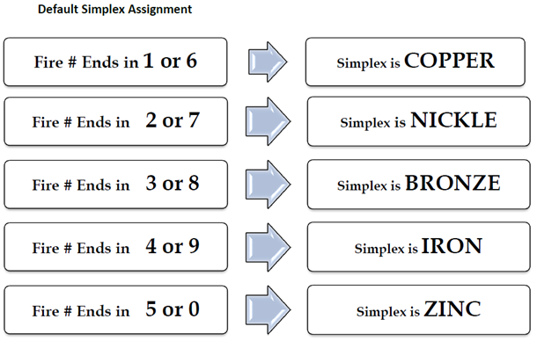
Default Simplex Assignment
Once an incident number is created, all assigned and responding parties will be able to reference the guidance provided below to ensure clear communications. The simplex assignment can be overridden in circumstances where warranted at the discretion of the Incident Commander. If this takes place the IC is responsible to notify the assigned resources, incoming resources immediately of the change.

Safety Check-In/Out Procedures
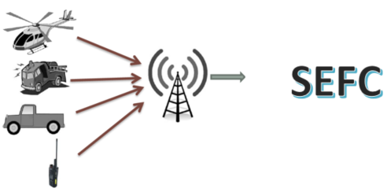
You will be required to check-In/Out with the “Southeast Fire Centre” when leaving the office and heading into the field using the radio or phone. When field work is related to wildfire response, radio is the preferred method of communication. Ensure to set up a check-in schedule with dispatch. SEFC Dispatch 250-365-4001. Refer to the repeater map on the next page to ensure you are using the correct repeater and tone.

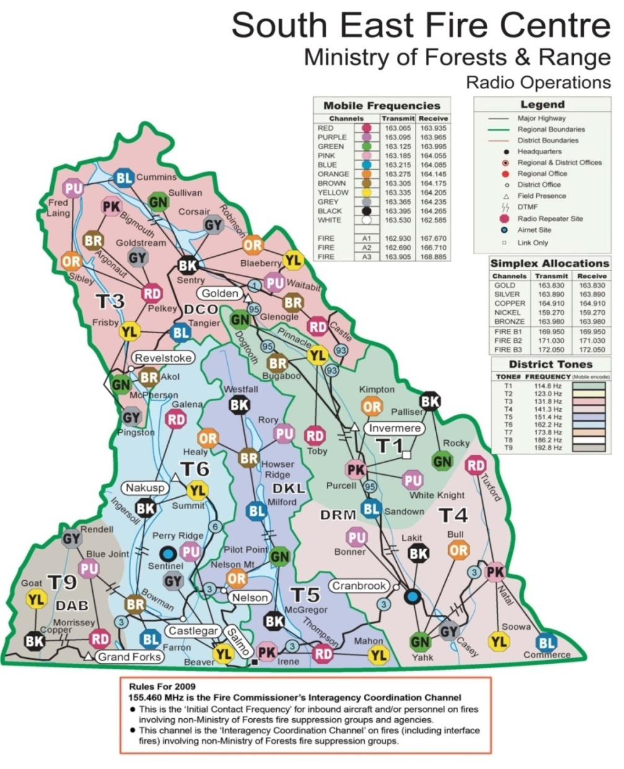
Repeaters

sefc type 3-4 incident commander updates
Mandatory Updates to Dispatch – For entry into PRT
- Position Checks
  - “Leaving Base”, “Onsite”, “Departing Site”, “On Good Roads” etc.
  - Confirm your manifest with dispatch when departing base
  - It is also important to advise dispatch when ON/OFF Red Alerts
- Number and Type of Resources Onsite
  - Don’t forget 1st Aid Units, Security Personnel, Heavy Equipment, # Equipment Operators, Flaggers, Industry Crews
- Quick Summary of Objectives For the Operational Period
  - E.g. “Gaining access to the fire and setting up relay tank”
  - E.g. “Establishing containment with fuel free and hose lay”
- Estimated Time of Completion & Safety Check In Requirements
  - Establish check in intervals and ETC
  - Also advise if you are overnighting so a 24 hr contact can be arranged
- Fire Size Updates
  - Specify whether it is an Estimated vs. Accurate fire size
- Fire Status and Incident Type Changes
  - Status: Out of Control, Being Held, Under Control, Out & Incident Type: Fire, Nuisance Fire, or Smoke Chase
Other Important Updates
- Significant Challenges or Safety Concerns: E.g. “Burning in steep rocky terrain, anticipate an extra day of patrol”
- Significant Increases or Decreases in Observed Fire Behaviour: Generally when a change in strategies and tactics takes place
- Any Referral to Medical Aid – Use of Sat Phone Preferred
- Response to all Regional Emergency Procedures will be coordinated directly through the SEFC (Medivac, Fatalities, Aircraft Emergencies, Environment Emergencies (Hazardous Spills), Interface Fires)
Resource Needs “Who to Call”
REQUEST FROM FIRE CENTRE – Generally for Initial Response
- Air Tanker Requests
- RW Bucket Support for Initial Response
- HTR (Rappel Crew, Belly Tanker, Hoist Extraction)
- Fire Origin & Cause Investigator Significant Human Caused Fires
- Natural Resource Officer Compliance Issues/Suspected Industry Fires
- Mutual Aid / Agency Support:
  - Fire Departments
  - Utilities (Hydro, Fortis)
  - RCMP
  - Traffic Control
  - CP/CN Rail
- Activation of Regional Emergency Procedures: Medivac, Fatalities, Aircraft Emergencies, Environment Emergencies (Hazardous Spills), Interface Fires
REQUEST FROM ZONE – Generally for ongoing support “Boots on the ground”
- Additional Crew (2nd IA Crew, Unit Crew)***
- Contract Resources (Contract Crew, Industry Faller, MTC)***
- Planned RW support (fill bladders, longline gear, crew pickup etc.)***
- Gear Orders
- Heavy Equipment / Water Tenders
- Logistics Support: Meals/Accommodations/Fuel
**These are Regional or Provincial Level Resources. Requests from the incident go to ZWCO to ensure local prioritization. Final approval/assignment will be by FC OSO (Contract Personnel), RABC (Aircraft), and RWCO (Unit Crews)
Air Tanker Requests
- State the objective: ex. “Holding action for crew to gain access”
- Values Threatened: Specific to ATR
- Updated Fire Size & Behaviour: If different from IFR
- Hazards: Powerlines, Visibility (smoke), Terrain, Unidentified Air Traffic
- Avoid information around strategies and tactics: “blanketing or boxing fires”, this can be discussed with the AAO upon arrival

Zone Organization Chart

contacts
Invermere Fire Zone 2022 Quick Reference
INVERMERE ZONE OFFICE: Box 189, 625 Fourth St., Invermere B.C V0A 1K0
LAT (n) 50 30.575 LONG (w) 116 01.717 853m
Fax: 250-342-4320

OFFICERS and CREWS

Zone/RO-Sat Phone: From cell phone 001 881-6224-74881 ZWCO NUMBER: 236-527-2020
 | Call Sign | Office | Work Cell
Sebastian Bichlmaier | SE 20 | 778-635-0103 | 250-342-5217
Nick Woode | SE 22 | 778-635-0116 | 250-341-8408
Robyn Canty | SE 23 | 236-527-2014 | 250-342-5219
Katherine Grahn (QFT, DTA) | SE 27 | 236-527-2015 | 250-341-1749
Maarty Meijer | SE 24 | 778-635-0114 | 250-342-5218
Christy Madson | SE 29 | 236-527-2016 | 250-341-1325
Brad Zuk (QFT)  Sat phone:001881 6414 28216 | SE 36 | 236-527-2045 | 250-688-0503
Mark Weis | SE 26 |  | 250-608-4264

OFA 3 - *

SE 210-Sat PHONE: 403-927-3423
 | Certifications | Call Sign | Work Cell
Nathan Pinchak | FIT, DTA | 210 A | 250-342-5216
Nick Donmoyer* | OFA 3 | 210 B | n/a
Eric Grier |  | 210 C | n/a
Cristina Sherren |  | 210 D | n/a

SE 220-Sat Phone: 403-927-3424
 | Certifications | Call Sign | Work Cell
Daniel Larsen* | FIT, OFA 3 | 220 A | 250-342-1676
Jerry Jellali* | Bucker, DTA, OFA 3 | 220 B | n/a
Chandler Bachtold |  | 220 C | n/a
Jack Kolesch |  | 220 D | n/a

SE 230 –Sat Phone: 403-927-3418
Kyle Rogers | Bucker | 230 A | 250-342-5289
David Postman | FIT | 230 B | n/a
Kieran Missellbrook* | OFA 3 | 230 C | n/a
Martha Kilian |  | 230 D | n/a

SE 240 – Sat phone: 403-927-3419
Megan Thibodeau | Bucker, DTA | 240 A | 250-341-1751
Blake Gooding | Bucker | 240 B | n/a
Brenton Burridge | OFA 3 | 240 C | n/a
Mitch Snow |  | 240 D | n/a

Location

PO Box 189
625 Fourth Street
Invermere BC
V0A 1K0

Directions:
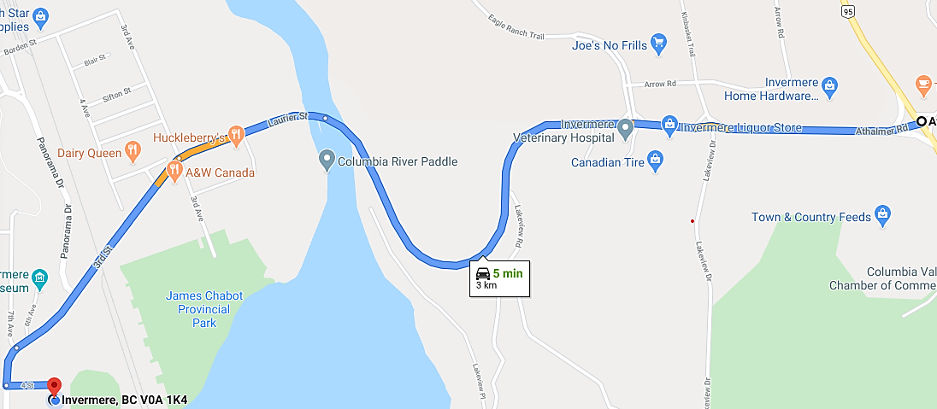

At the junction of Highway 93/95 and the Athalmer Highway, follow signs and head west into Invermere. Proceed across the Columbia River bridge, through the streetlights, to the next set of streetlights and turn left (East) on Fourth Street. After the Services BC building, take next right (South). Across from the Invermere Fire Hall, into the fenced compound. The Invermere Fire Zone Office is in the second trailer in the SE corner of the yard.

Fuel Caches

Geographic | Contact | Elevation (m) | Latitude | Longitude
Fairmont Airport | Tex Deagnon:  C: 250-341-7150 | 811 | 50°19.49 | 115°52.24
Invermere Base | 8 Drums (can be moved to remote location as needed) | 853 | 50°30.575 | 116°01.717
Invermere Airport  Babin Air:  250-342-3565 | Glacier:  250-341-7164  Bighorn:  250 489 2517 | 874 | 50°31.170 | 116°00.282
Kootenay Crossing Fuel Cache | Parks Fire Duty Officer: 250-342-1059 |  | 50°53.089 | 116°03.134
Panorama (R.K. Heli-Ski) | Graham Holt:  250-341-5211 | 1166 | 50°27.550 | 116°14.470
Bobbie Burns Lodge | 250-346-3191 | 1364 | 50°57.002 | 116°55.788
Bugaboo Lodge | 250-346-3334 | 1497 | 50°45.300 | 116°42.300
White River | 2 Drums | 1319 | 50°10.746 | 115°15.257
Parson | 2 Drums | 787 | 51°03.826 | 116°38.448
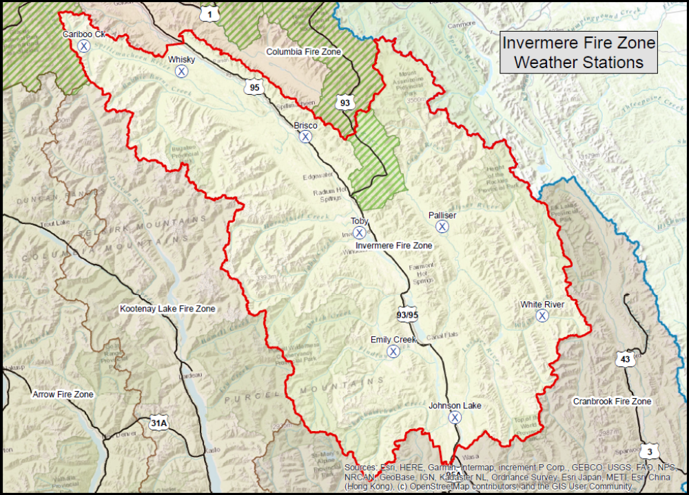
Fire Zone | Station Name | Latitude | Longitude | Elevation (m)
Invermere | Brisco | 50° 49.158 | 116° 14.694 | 930
Invermere | Emily Creek | 50° 08.705 | 115° 58.634 | 1190
Invermere | Johnson Lake | 49° 56.667 | 115° 45.500 | 853
Invermere | Palliser | 50° 29.677 | 115° 39.987 | 1100
Invermere | Toby | 50° 30.770 | 116° 03.320 | 894
Invermere | Whiskey | 51° 03.920 | 116° 47.100 | 1300
Invermere | White River | 50° 11.100 | 115° 16.058 | 1357

Weather Stations

Food & Accomodation

There are many hotels and lodges in the area. The Zone office can assist with accommodation. There are plenty of restaurants, golf courses and lodges that serve food in the Zone. Crew Supervisors/Crew Leaders can organize their own food. Late night/early morning food options are limited as such, grocery stores may be your best option and are listed below.
Grocery Stores

Name | Address | Hours
Sobeys | 750 4 St, Invermere, BC V0A 1K0 | 0700 - 2200
AG Valley Foods | 906 7th Ave, Invermere, BC V0A 1K0 | 0700 – 2200
No Frills | 471 Arrow Rd, Invermere, BC V0A 1K2 | 0800 – 2100
Radium Mountain Side Market | 7546 Main St E, Radium Hot Springs, BC V0A 1M0 | 0800 - 2100
Fairmont Mountain Side Market | 4992 Fairmont Frontage Rd #8, Fairmont Hot Springs, BC V0B 1L0 | 0800 - 2100
Canal Flats Family Foods | 8953 Arbuckle St, Canal Flats, BC V0B 1B0 | 0800 - 2000

Places of Interest
Kinsmen Beach
1720 4 Ave, Invermere, BC V0A 1K7
Valley Fitness Centre
722 14th Street - Invermere, BC V0A 1K0
James Chabot Park
Athalmer, BC
Mount Nelson Athletic Park
1500 14th St, Invermere, BC V0A 1K0

Zone map
